Unit 8 ~ Learning Guide
Answer Booklet
University Affiliation

Students Name
Date of Submission
Inducting a current
- Electromagnetic or magnetic induction is the production of an electromotive force across an electrical conductor in a changing magnetic field.
- Magnetic flux is defined as the number of magnetic field lines passing through a given closed surface. Its usually denoted using the Greek letter Phi. (Φ or Φ_{B}.). the Magnetic flux formula is given by ϕB=B.A=BAcosΘ Where,
- Φ_{B} is the magnetic flux.
- B is the magnetic field
- A is the area
- θ the angle at which the field lines pass through the given surface area
Magnetic flux is usually measured with a flux meter. The SI and CGS unit of magnetic flux is given below:
- SI unit of magnetic flux is Weber (Wb).
- The fundamental unit is Volt-seconds.
- The CGS unit is Maxwell.
Illustration

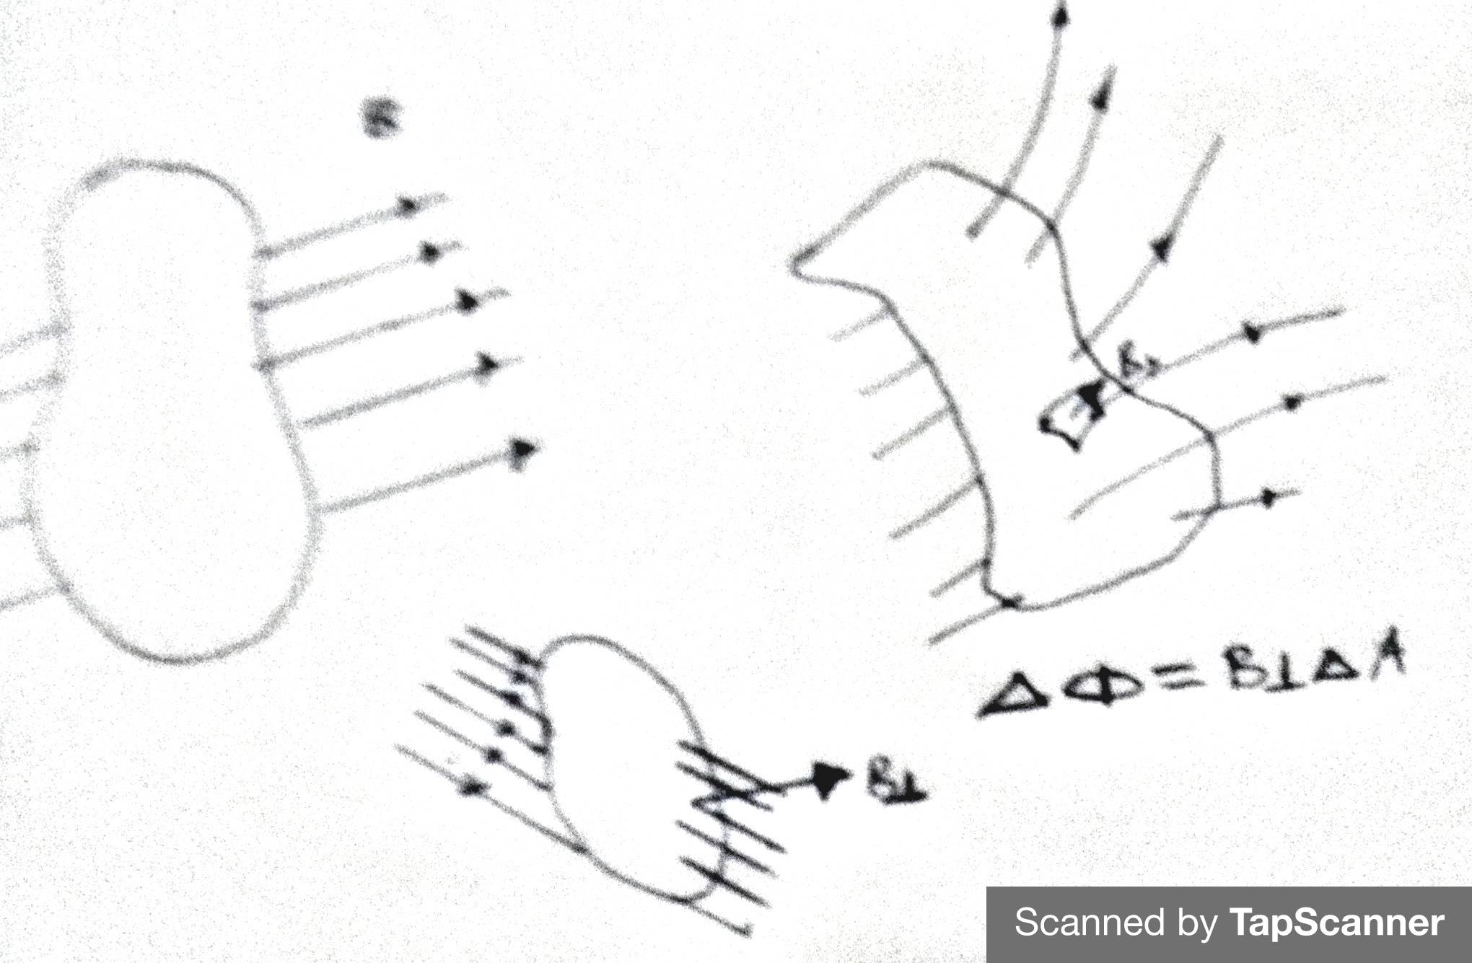

The contribution to magnetic flux for a given area is equal to the area times the component of magnetic field perpendicular to the area. For a closed surface, the sum of magnetic flux is always equal to zero (Gauss' law for magnetism). No matter how small the volume, the magnetic sources are always dipole sources (like miniature bar magnets), so that there are as many magnetic field lines coming in (to the south pole) as out (from the north pole).

- A = 22/7*2cm²
=12.6cm²
B=0.18 x 10⁻²
N= 50turns
Using the emf induced formula:
B.A for one quarter rotation = (0.00126x0.18x10⁻²)
Therefore, induced emf:

= (0.00126x0.18x10⁻²)
0.10

=4.13V

- A wire of length 0.50m passes over a square magnetic field (0.75m per side) at
a speed of 10m/s. The magnetic field is uniform and has a strength of 0.75T,
directed upwards. What EMF is induced in the ends of the wire and which way will the current flow?
E = −N dΦB = −1 × S∆B = − (0.4m) 2 × (0.2T − 0.1T) = −3.2 × 10⁻³V.
Dt ∆t 5s

- Given;
A=225
N= 24turns
B=3.6 x 10-2
T= 0.15s
From Faradays Law emf induced;

E= {24} 22/7 R² {B2 – B1}
dt
E= 6.1V

- Emf = Flux/ Time
Hence flux = - emf x time
For n no of flux turns = n x emf x time

Flux= 100x2 x 0.001
= 0.2V-s

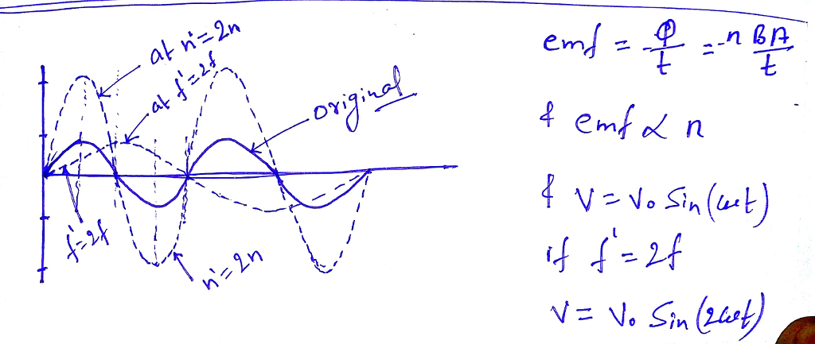

- Given;
A=225
N= 24turns
B=3.6 x 10-2
T= 0.15s
From Faradays Law emf induced;

E= {24} 22/7 R² {B2 – B1}
dt
E= 6.1V

- An airplane with a wingspan of 12.0 m travels at right angles through a magnetic field of strength 5.0 x 10-3T. An emf of 1.5 V is induced between the ends of the wingtips. How fast was the airplane moving?

Given : B=1.75×10−5T l=40m

Speed of aircraft v=1080 km/h =1080×185​=300 m/s

Emf induced E=Bvl

E=(1.75×10−5)(300)(40)

=0.21 volts

- Right

- A) ΔΦ = -0.33 Wb, ε = 23.1 V

B) ΔΦ = 0 Wb, ε = 0 V

C) ΔΦ = -0.33 Wb, ε = 23.1 V

D) ΔΦ = 0 Wb, ε = 0 V

- a.) The initial flux is the number of
turns x initial magnetic flux x area
=20 x 0.5 x 1.5 x 10^⁻³
=0.015Wb

b.) The induced emf is negative of the rate of change of flux

E= {nA(B_i-B_f)}
{t}={20x 1.5x 10^⁻³(0.5-0.6)}{0.1}
=0.03V

c.) If the field is raised back, the induced EMF will be reversed.

E'=-E
=-0.03V

- A flat coil of wire (0.1m by 0.2m) has 50 turns. At t=0, the coil is perpendicular to a
magnetic field B = 0.18T, (its normal is parallel to the direction of the field). The coil is
rotated 30° over a period of 0.1 seconds.

  - What is the induced emf?

At t=0, flux = BA =0.18 X 50 X 0.1 X 0.2- 0.18Tm²
At t=0.1, flux = BAcos30 =0.18 X cos30 = 0.156Tm²
Therefore emf= (0.18-0.156)/0.1
=0.241V

b. What would the emf be if the coil is now rotated from this position to 90° in 0.1s?
Final Flux = BA cos90 = 0
Therefore, emf = 0.18/0.2
=0.2V

- A wire is oriented into a loop that has a diameter of 1 cm. This loop is then pulled closed
in 0.5 s. If there was a magnetic field directed through the loop of 0.25 T, what emf is
induced?
= - N d/dt = - N /t
= _{f} - _{i}
_{f} = 0
_{i} = [1.6 T] [0.20 m²] = 0.32 T-m²
= _{f} - _{i} = - 0.32 T-m²
= - N d/dt = - N /t = (200)(0.32/0.020) V
= 3200 V

Lenz’s Law
  - Lenz’s states that in electromagnetic induction, the direction of induced current is such that it opposes because of its creation. It’s similar to Newtons, third law of motion (of action reaction) because direction of induced current is opposite to the force which we apply. Hence action i.e. motion and reaction ie induction of current are equal and opposite.
  - Clockwise
  - Clockwise
  - Counter clockwise
  - Counter clockwise
  - Solenoid a will be the positive pole
  - A.) No induced current
B) counter-clockwise
C) clockwise
D) clockwise
8. A) Unchanged
B.) Y axis = current, X axis = time, Third Graph
C.) Stay Unchanged
D.) As the magnet begins to fall through the loop, the current would be show in ____Case 2__, but just after the magnet exits the loop it will look like ___Case 1____.
E.) Centre of the Loop
F.) Positive. As the magnet approaches, the induced current creates an upward magnetic field (as in case 2) to oppose the extra down-directed field lines from the magnet. The current reverses direction when the magnet moves away because now the field is decreasing
9. A.) Velocity
B.) Rotates around a vertical axis.
C.) Forces act to rotate the loop clockwise. When loop is vertical, current switches sign and the forces reverse, in order to keep the loop in rotation. Its basically how a motor operates. The loop is rotated clockwise only therefore eliminating the need of opposite forces.
D.) The current induced in the circuit is the emf divided by the resistance Or:
I= Blv
R
E.) v = speed of the moving conductor = 278 m/s, 30° above the local horizontal
B = magnetic field of strength = 5.0 x 10⁻⁵ T, pointing vertically upward from the surface of the earth
θ = angle between the direction the conductor is moving, and the direction of the magnetic field
θ = 90° - 30° = 60°
L = length of the conductor = 80 m (wing tip to wing tip)
E = induced emf = ?

E = -BLv sinθ

(The minus sign comes from Lenz's law.)

E = -(5.0 x 10⁻⁵ T) (80 m) (278 m/s) (sin60°) ≅ -0.963 volts

10. A.) When the coil starts coming out of the magnetic field.

B.) 0.02 x 1 x 2=0.004V

C.) Magnetic field flux through the coil is decreasing therefore the induced Magnetic field will be in the same direction and thus the current will induce the coil counter clockwise.

11. B= 0.25T
emf = 1.5V
l=0.25m
t=?
From:
0.25x0.25 x1
1.5
t=0.04167s

Motors & Generators:
  - Once a motor has successfully started and reached its load current level, its cooling circuit can dissipate the additional heat produced by the starting current. Restarting the motor before all extra heat has been dissipated, however, will add more heat (kW) to the heat already there. In that case, each subsequent start will add even more heat, raising the motor temperature until some component fails.

  - Due to overloading/overheating, as a result of the additional heat descippitated by the cooling circuit from the starting current.

  - A.) I=V/R
0.76R=12
R= 15.8Ohm

B.) V=1R
V= (15.8X0.76)
V= 12.01V
C.) This is the electromotive force or "voltage" that opposes the change in current which induced it.
4. A.) When the motor first starts up, the back emf is zero. You can use Ohm's law to get the initial current I₀.

I₀ = E/R = (120 V) / (5.0 Ω)
= 24.0 A

B.) When the motor reaches full speed, the voltage of the circuit becomes the difference between the line voltage and the back emf. Use Ohm's law to get the final, lower current I_{f} based on the reduced voltage E_{f}. The resistance is the same.

E_{f} = (120 V) - (108 V)
= 12 V

I_{f} = E_{f}/R = (12 V) / (5.0 Ω)
= 2.4 A

The circuit diagram will be a single closed loop with a battery of 120 V in opposition to a battery of 108 volts, in series with a 5.0 Ω resistor.

Transformers
- The major difference between step-up and step-down transformer is, step-up transformer raises the output voltage (more secondary winding turns than primary winding turns) , whereas step-down transformer reduces the output voltage.( more primary winding turns than in secondary)
- Stepdown
- This is because a change in current cannot be generated by DC; meaning that there is no changing magnetic field to induce a voltage across the secondary component.
- A.) Stepdown

B.) Np =Vp
Ns Vs
600 = 1000v
100 Vs
Vs= 166.67V

C,) Vp Ip = Vs Is
1000x100=166.67x Is
Is= 599.98A

D.) E= -n do
Dt
=0
- A.) If you have 6.7V as input, what is the expected output voltage?
110 = 6.7V
880 = ?
=53.6V

B.) 6.7 x 4.1 = 53.6 x Is
27.47 = 53.6Is
Is = 0.5A

C.) Input Power = VpIp Output Power=VsIs
=53.6*0.5
=26.8W
=6.7*4.1
=27.47W

D.) Efficiency = 26.8
27.47
=0.9
- Efficiency of the transformer is given by
N= Output – Power
Input – Power
N=Output – Power
VA
0.75 = Output-Power
100 x 0.01
Output Power =0.75W
Therefore;
N₂ = I₁
N₁ I₂
250 = 0.01
500 I₂
I₂ = 0.02A

- A.) Np = Ns Vp = 30 120V
Vs 9V
=400 Turns

B.) Ip = Is Vs = 0.4A 9v
Vp 120V
=0.03A
C.) P = IsVs = (0.4A) * (9V)
=3.6W
- The induced primary voltage limits the flow of primary current. In the ideal transformer the current value is zero. In non-ideal transformers this current is greater than zero. Since there are no transformer losses, power in equals power out.

- A.) when the switch is closed, there is a change in magnetic flux thus current is induced in the anticlockwise direction in the coil in the right side. This in return induces a deflection on the galvanometer towards the clockwise direction

B.) No change in flux is recorded when the switch remains closed hence no current is induced therefore no deflection.
C.) when the switch is opened, the current induced in the right coil is in clockwise direction and due to shift in flux, the galvanometer deflects counterclockwise.
D.) No current is induced in the right-side loop since there is no change in flax thus no deflection.

END

